WEEK 4:

Comprehensive Data Science Report and Insights Presentation Plan

SUBMITTED BY:
Krishna Yadav

COURSE:
Bachelor of Computer Applications (BCA)

INTERNSHIP:
Data Science Internship

Organization: YuvaIntern/NSDC

Week: Week 4 Final Report
Executive Summary
Student performance analysis is an important application of data science that can help educational institutions understand the factors affecting students' academic outcomes. Student performance can be influenced by several factors, including study time, attendance, previous academic performance, parental support, participation in activities, and other academic and personal factors.
The proposed project, Student Performance Analysis Using Data Science, focuses on analysing student-related data to identify meaningful patterns, trends, and factors associated with academic performance. Python-based data science techniques will be used to organize, analyse, visualize, and interpret the hypothetical dataset.
The project follows a structured data science approach beginning with data understanding and preprocessing, followed by Exploratory Data Analysis (EDA), visualization, identification of important patterns, interpretation of findings, and development of actionable recommendations.
The analysis will use statistical summaries and visualizations such as bar charts, histograms, scatter plots, box plots, and correlation heatmaps to understand relationships between different variables and student performance.
The expected analysis may identify patterns such as the relationship between study time and academic scores, the effect of attendance on performance, differences in performance across student groups, and the importance of other relevant academic factors.
The main purpose of the project is not only to analyse student performance but also to convert analytical findings into useful insights that can support teachers, educational institutions, students, and other stakeholders in making informed decisions.
Since this is a hypothetical project, the findings presented in this report represent expected insights and planned analytical outcomes rather than results obtained from an actual dataset.
Overall, the project demonstrates how data science can be used to understand educational performance, identify areas for improvement, and support data-driven academic decision-making.

Project Overview and Purpose

Project Overview
The Student Performance Analysis Using Data Science project focuses on analysing student-related information to understand the factors that may influence academic performance.
The proposed project uses a structured Python-based data science approach to examine student data, identify meaningful patterns, and present insights through clear visualizations. The analysis can help educational stakeholders understand areas where students may need additional academic support.
The project considers various possible attributes such as:
- Study time
- Attendance
- Previous academic scores
- Assignment performance
- Participation in academic activities
- Parental or educational support
- Student demographic and academic information
The project is designed as a hypothetical data science project. No real student dataset is required for this planning exercise.
Project Purpose
The primary purpose of the project is to understand student academic performance through data analysis and visualization.
The project aims to:
- Analyse student performance patterns.
- Identify factors that may be associated with academic outcomes.
- Explore relationships between different student-related variables.
- Identify students or groups that may require additional academic support.
- Present analytical findings through simple and meaningful visualizations.
- Provide actionable recommendations based on the expected insights.

Importance of the Project
Educational institutions generate and maintain different types of student information. Analysing this information can provide useful insights that may not be easily identified through manual observation.

Data-driven analysis can help teachers and institutions understand performance trends, identify potential areas of improvement, and make better-informed academic decisions.

Expected Benefits
The proposed analysis can provide several potential benefits:
- Better understanding of student performance.
- Identification of important performance-related factors.
- Early identification of students who may need additional support.
- Improved academic planning.
- Data-driven decision-making for educators.
- Clear communication of performance trends through visualizations.
Project Scope
The project will focus on data analysis, visualization, interpretation of findings, and recommendations related to student performance.
The project does not aim to make final decisions about individual students. Instead, the analysis is intended to provide supporting information that educational stakeholders can use alongside their professional judgment.

Methodology Review
Introduction
The proposed Student Performance Analysis project follows a structured data science methodology. The methodology ensures that the data is properly prepared, explored, visualized, and interpreted before drawing conclusions.
The overall process will be carried out using Python and appropriate data science libraries.

Data Science Methodology
The proposed methodology includes the following stages:
1. Data Collection
Relevant student information will be collected from a suitable educational dataset. Possible variables may include attendance, study time, previous scores, assignment marks, and final academic performance.

2. Data Understanding
The dataset will be examined to understand its structure, variables, data types, number of records, and target performance variable.

3. Data Cleaning
The data will be checked for:
Missing values
Duplicate records
Incorrect data types
Inconsistent values
Unusual or extreme observations
Appropriate techniques will be used to handle these issues.

4. Exploratory Data Analysis
EDA will be performed to identify patterns, trends, relationships, and differences within the student data.
Both univariate and bivariate analysis will be considered.

5. Data Visualization
Charts and graphs will be created to make important patterns easier to understand. Suitable visualizations may include:
- Bar charts
- Histograms
- Scatter plots
- Box plots
- Pie charts
- Correlation heatmaps

6. Analysis and Interpretation
The results of the analysis will be interpreted to identify factors that may be associated with student performance.

7. Insights and Recommendations
The identified patterns will be converted into meaningful insights and practical recommendations for students, teachers, and educational institutions.
Proposed Workflow
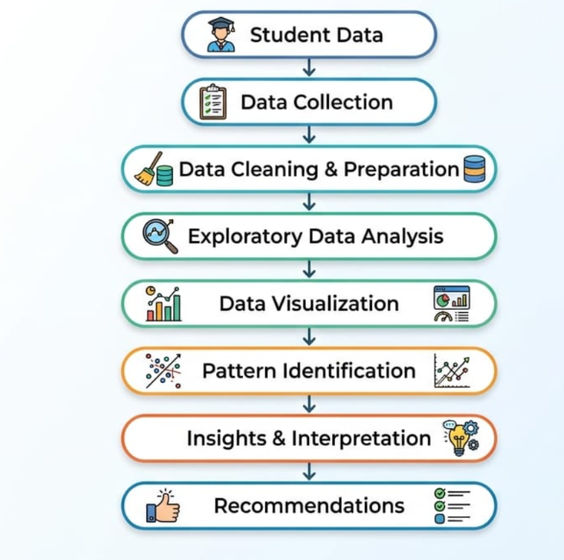
Methodology Overview

Introduction

The proposed Student Performance Analysis Using Data Science project follows a systematic methodology for transforming student-related data into meaningful insights.

The methodology focuses on understanding the available data, preparing it for analysis, exploring important patterns, creating appropriate visualizations, interpreting the results, and developing practical recommendations.

The overall approach is designed to ensure that conclusions are based on systematic analysis rather than assumptions.

Overall Data Science Process

The proposed project follows the following sequence:
Data Understanding
Student Data
Final Report
Actionable Recommendation
Insight and Interpretation
Relationship Identification
Data visualization
Exploratory Data Analysis
Data Cleaning
Data Analysis Approach
The analysis will examine both individual variables and relationships between variables.

Univariate Analysis

Individual variables will be analysed separately to understand their distribution and characteristics.
Examples include:
- Distribution of student scores
- Attendance distribution
- Study-time distribution
- Assignment performance

Bivariate Analysis
Two variables will be analysed together to identify possible relationships.
Examples include:
- Study time vs. final score
- Attendance vs. final score
- Previous score vs. final score
- Assignment performance vs. final score

Multivariate Analysis
Multiple variables will be considered together to obtain a broader understanding of factors associated with student performance.
Purpose of the Methodology
The methodology aims to:
- Identify important patterns in student performance.
- Understand relationships between academic factors.
- Present findings through clear visualizations.
- Identify potential areas for academic improvement.
- Convert analytical results into useful recommendations.

Expected Output
The final analysis is expected to produce a structured set of visual findings, key insights, and recommendations that can be communicated effectively to both technical and non-technical stakeholders.

Findings and Expected Insights

Introduction

As this project is a hypothetical data science planning exercise and no actual dataset is provided, the findings presented in this section are expected insights that could be obtained after analysing a suitable student performance dataset.

These expected insights are based on commonly analysed academic factors and are intended to demonstrate how data science findings would be interpreted and communicated.

Expected Finding 1 – Study Time and Academic Performance

Students who spend more time studying may show differences in their academic performance compared with students who spend less time studying.

Expected Insight:
Study time can be examined as one of the possible factors associated with academic performance.

Expected Finding 2 – Attendance and Performance

Attendance can be analysed to understand whether students with higher attendance levels show different academic outcomes.

Expected Insight:
Attendance patterns may provide useful information for identifying students who could benefit from additional academic support.

Expected Finding 3 – Previous Academic Performance

Previous examination scores can be compared with current or final performance.

Expected Insight:
Previous academic performance may provide an indication of a student's current academic progress.

Expected Finding 4 – Assignment Performance

Assignment and continuous assessment scores can be analysed in relation to final academic performance.

Expected Insight:
Consistent performance in assignments may be associated with stronger overall academic outcomes.

Expected Finding 5 – Performance Differences Between Student Groups

The analysis may reveal differences in academic performance across different student groups or categories.

These differences should be investigated carefully to understand whether they are associated with meaningful academic factors rather than being interpreted as causal relationships without sufficient evidence.

Expected Finding 6 – Identification of Students Requiring Support

Data analysis may help identify performance patterns that indicate where additional academic support could be useful.

Examples may include:

- Consistently low assessment scores.
- Low attendance combined with weak performance.
- Declining performance over time.
- Difficulty in particular academic areas.

Important Interpretation Principle

The project will distinguish between correlation and causation. A relationship between two variables does not automatically mean that one variable causes the other.

Therefore, the final conclusions should be based on evidence from the analysis and should avoid unsupported assumptions.

Suggested Visual

Add a bar chart or scatter plot showing an example relationship such as:

Study Time vs. Final Score

Label it clearly as:

“Illustrative Visualization – Expected Analysis”

This makes it clear that the chart is a mock-up and not an actual result.
Visualization Strategy – I
Purpose of Data Visualization
Data visualization is an important part of the student performance analysis because graphical representations make patterns, differences, and relationships easier to understand.
The proposed visualizations will convert numerical information into simple charts that can be understood by teachers, students, administrators, and other stakeholders.

Student Performance Distribution
Histogram
A histogram can be used to display the distribution of students' final scores.
Purpose:
- Understand the overall score distribution.
- Identify common performance ranges.
- Detect unusually low or high scores.
- Observe whether scores are concentrated around a particular range.
X-axis: Final Score
Y-axis: Number of Students
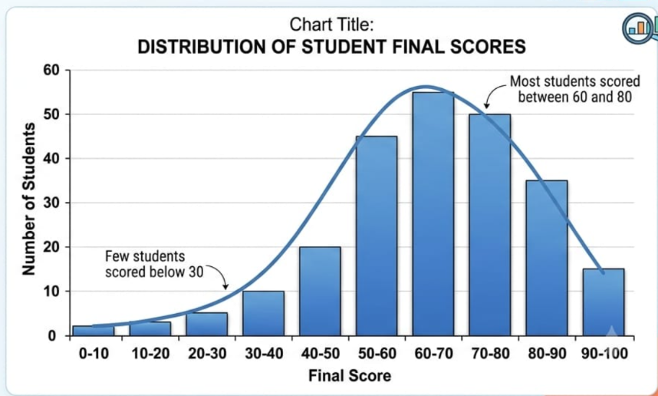
Added Chart Here
Study Time vs. Final Score

Scatter Plot
A scatter plot can be used to examine the relationship between study time and final academic score.
X-axis: Study Time
Y-axis: Final Score
Purpose:
- Identify possible relationships between study time and performance.
- Observe whether higher study time is associated with different score patterns.
- Identify unusual observations.

Added Chat Here
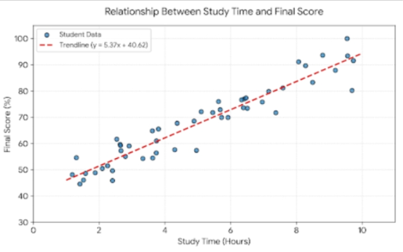
Attendance and Academic Performance

Attendance percentage can be compared with final scores to explore possible relationships between regular attendance and academic performance.
X-axis: Attendance Percentage
Y-axis: Final Score
Purpose:
Examine attendance-related patterns.
Identify possible performance differences.
Support further investigation of academic engagement.
Key Visualization Principle
The charts should be simple, properly labelled, and relevant to the question being analysed. Titles, axis labels, legends, and appropriate scales should be included wherever necessary.
The objective is not to create a large number of charts, but to select visualizations that provide clear and meaningful information.

Visualization Strategy – II

Correlation Heatmap

A correlation heatmap can be used to examine relationships among numerical variables in the student performance dataset.

Possible variables may include:

- Study Time
- Attendance
- Previous Score
- Assignment Score
- Final Score

Purpose:

- Identify variables that show stronger relationships.
- Understand relationships between academic factors.
- Support further analysis and variable selection.

Performance by Student Group

A bar chart can compare average academic performance across different student groups.

For example, students could be grouped according to:

- Study-time category
- Attendance category
- Performance category

X-axis: Student Group
Y-axis: Average Score

Purpose:

- Compare performance between groups.
- Identify groups with relatively higher or lower performance.
- Support targeted academic recommendations.

Performance Category Distribution

Recommended Visualization: Pie Chart or Bar Chart

Students can be categorized into performance levels such as:

- High Performance
- Average Performance
- Needs Improvement

The chart can show the proportion or number of students in each category.

Purpose:

- Provide a quick overview of overall performance.
- Help stakeholders understand the distribution of academic outcomes.
- Identify whether a significant group may require additional support.

Box Plot for Outlier Detection

A box plot can be used to identify unusually high or low scores.

Purpose:

- Detect potential outliers.
- Understand the spread of scores.
- Compare score distributions between different groups.

Visualization Selection Principle

Each visualization should answer a specific analytical question. The project will avoid unnecessary charts and focus on visuals that clearly communicate important patterns and support the final conclusions.

The visualizations will also be designed with clear titles, labels, and explanations so that non-technical stakeholders can understand the findings easily.
Insights and Analysis
Introduction
The purpose of the analysis is to convert patterns observed in the student performance data into meaningful insights. Since the project is hypothetical and no actual dataset is provided, the insights described below represent expected analytical outcomes rather than confirmed findings.

Academic Engagement and Performance
Study time, attendance, and assignment participation can be examined to understand their relationship with academic performance.
Expected Insight:
Students showing stronger academic engagement may demonstrate different performance patterns compared with students with lower engagement.
Previous Performance as an Indicator
Previous academic scores can be compared with current or final scores.
Expected Insight:
Previous performance may provide useful information for understanding a student's academic progress and identifying students who may need additional support.

Identifying Performance Gaps
The analysis can be used to identify groups of students with relatively lower academic performance.
Possible indicators include:
- Low final scores.
- Low assignment performance.
- Irregular attendance.
- Declining academic performance.
- Low study-time levels.
Expected Insight:
Identifying such patterns early may help educational institutions provide appropriate academic support.

Relationship Between Variables
Scatter plots and correlation analysis can be used to examine relationships between factors such as:
Study Time ↔️ Final Score
Attendance ↔️ Final Score
Previous Score ↔️ Final Score
Assignment Score ↔️ Final Score
These relationships can help determine which variables deserve further investigation.

Importance of Data-Driven Analysis
Data analysis can provide evidence-based information that supports academic decision-making. However, statistical relationships should not automatically be interpreted as causal relationships.
Other factors that are not included in the dataset may also influence student performance.

Key Insight Summary
The expected analysis can help stakeholders:
- Understand overall student performance.
- Identify important academic patterns.
- Detect possible performance gaps.
- Identify areas where additional support may be useful.
- Make more informed academic decisions.
Suggested Visual:
Analysis
Patterns
Academic Data
Insight
Academic Support
Improved Decision-Making
Actionable Insights

Introduction

The main objective of data analysis is to convert findings into practical actions. The insights obtained from student performance analysis can help teachers and educational institutions make better-informed academic decisions.

Since this is a hypothetical project, the recommendations below represent possible actions based on expected analytical findings.

Identify Students Requiring Additional Support

If the analysis identifies students with consistently low scores, low attendance, or weak assignment performance, these students can be considered for additional academic support.

Possible Action:

- Provide extra classes or doubt-solving sessions.
- Monitor academic progress regularly.
- Provide personalized learning resources.

Encourage Regular Attendance

If attendance is found to have a meaningful relationship with performance, institutions can encourage students to maintain regular attendance.

Possible Action:

- Monitor attendance trends.
- Identify repeated absenteeism.
- Communicate with students regarding attendance issues.

Promote Effective Study Habits

Analysis of study time and performance may provide insights into students' learning habits.

Possible Action:

- Encourage structured study schedules.
- Provide study-planning guidance.
- Promote consistent revision and practice.

Monitor Continuous Assessment

Assignment and assessment performance can be used to monitor student progress throughout the academic period.

Possible Action:

- Track assignment performance regularly.
- Identify declining performance early.
- Provide feedback before final examinations.

Support Data-Driven Academic Planning

Teachers and administrators can use aggregated performance insights to identify areas where students commonly experience difficulties.

Possible Action:

- Improve teaching strategies.
- Organize targeted revision sessions.
- Develop additional learning materials.
- Focus academic resources on areas with greater need.

Create an Early-Support Framework

A data-driven monitoring framework can help identify potential academic difficulties at an early stage.

Proposed Process:

Student Data

Performance Monitoring

Identify Risk Patterns

Academic Support

Progress Monitoring

Improvement Assessment

Responsible Use of Student Data

Student performance information should be used responsibly. Data analysis should support students rather than unfairly label or penalize them.

Any academic intervention should consider multiple factors and should not rely on a single data point or prediction.

Presentation Strategy for Non-Technical Audience

Introduction
The findings of a data science project should be communicated in a simple and understandable way. Many educational stakeholders may not have a technical background, so the presentation should focus on the meaning and practical importance of the findings rather than complex technical details.

Presentation Objective
- The main objective is to explain:
- What problem was analysed?
- What patterns were identified?
- What do the findings mean?
- How can the findings help students and teachers?
- What actions can be taken based on the insights?

Recommended Storytelling Structure
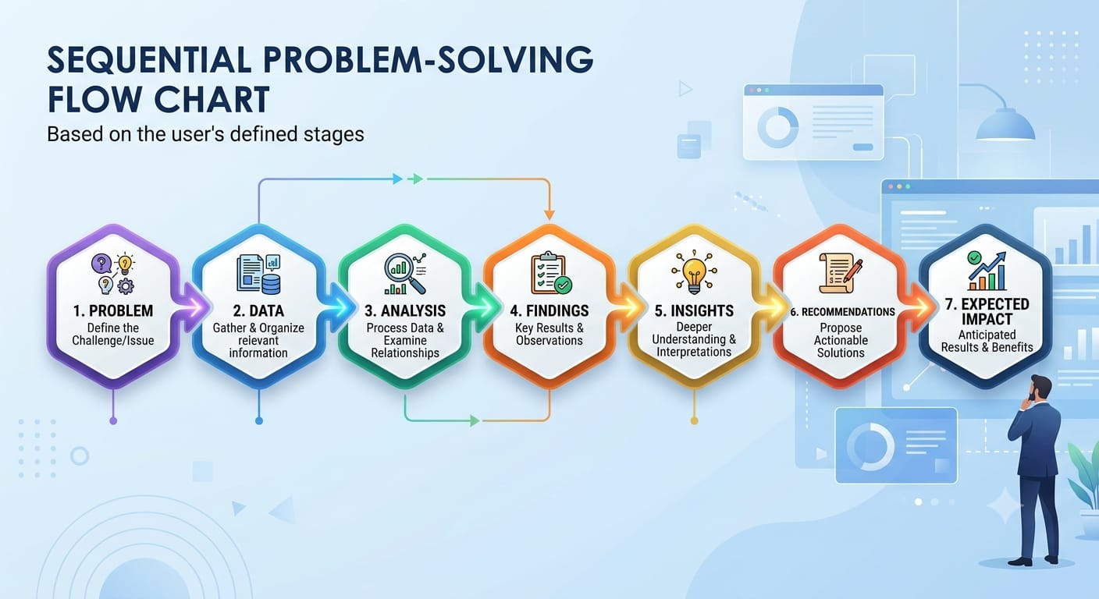
The presentation will follow a simple storytelling approach:
This structure allows the audience to understand the project from the original problem to the proposed solution.

Explain Technical Concepts Simply
Technical terms should be explained using simple language.
For example:
Correlation:
Instead of using a complex statistical explanation, describe it as a way to understand whether two variables tend to change together.
Outlier:
Explain it as an observation that is unusually different from most other observations.

EDA:
Explain it as the process of exploring data to understand patterns and identify important information.

Use Clear Visualizations
The presentation should use charts and diagrams instead of large tables of numbers.
Recommended visuals include:
- Student score distribution
- Study time vs. final score
- Attendance vs. performance
- Performance by student group
- Correlation heatmap
- Key insight diagram
Each visualization should have a clear title and a short explanation.

Focus on Business/Educational Impact
Instead of focusing heavily on Python code or statistical formulas, the presentation should explain how the findings can support:
- Early academic support
- Better teaching strategies
- Student progress monitoring
- Academic planning
- Data-driven decision-making

Suggested Presentation Flow
Introduction – Explain the student performance problem.
Objective – Explain what the project aims to understand.
Data – Introduce the types of information analysed.
Methodology – Briefly explain the analysis process.
Visual Findings – Present the most important charts.
Key Insights – Explain what the findings mean.
Recommendations – Explain possible actions.
Future Scope – Discuss possible improvements.
Conclusion – Summarize the overall value of the project.

Final Communication Principle
The presentation should answer one main question:
“How can student performance data help educational stakeholders make better academic decisions?”

The goal is to make the results clear, concise, evidence-based, and actionable for a non-technical audience.
Recommendations
Introduction
Based on the expected insights from the student performance analysis, several recommendations can be proposed to improve academic monitoring and support data-driven decision-making.
These recommendations are hypothetical because the project does not use an actual student dataset.

Provide Targeted Academic Support
Students showing consistently low academic performance can be identified for additional support.
Possible measures include:
- Personalized learning materials
- Extra classes
- Doubt-solving sessions
- Regular academic guidance

Monitor Attendance Regularly
Attendance information should be monitored to identify unusual patterns of absenteeism.
Students with repeated attendance issues can be provided appropriate guidance and support.

Encourage Consistent Study Habits
Educational institutions can encourage students to develop structured and consistent study routines.
Study-planning resources, revision schedules, and regular practice can help students maintain academic consistency.

Use Continuous Performance Monitoring
Instead of evaluating students only during final examinations, academic performance can be monitored throughout the semester.
Regular assessment can help identify declining performance at an earlier stage.

Use Data to Improve Teaching Strategies
Aggregated student performance insights can help teachers identify topics or areas where many students are facing difficulties.
Teachers can then:
- Provide additional explanations.
- Conduct revision sessions.
- Create supplementary learning materials.
- Adjust teaching strategies where appropriate.
Develop an Early Intervention System
A future system could combine attendance, assessment scores, previous performance, and other relevant variables to identify students who may benefit from early academic support.
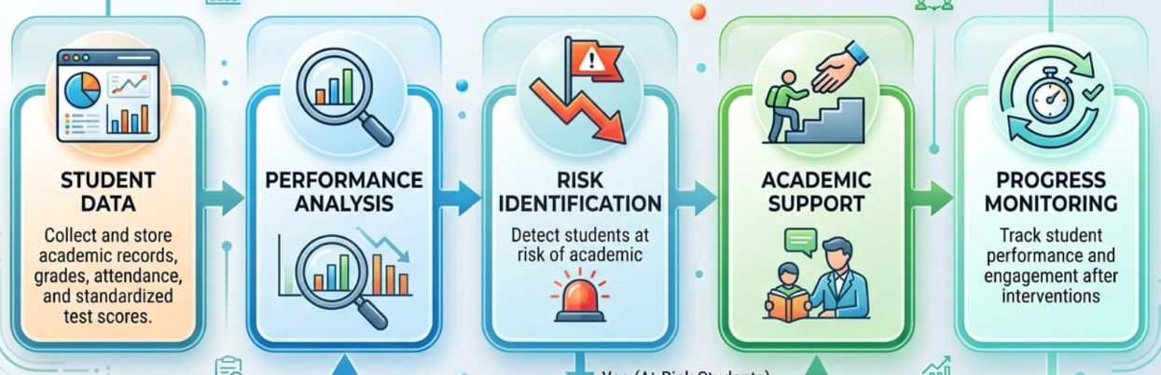
Proposed Process:
Protect Student Privacy

Student data should be handled responsibly and securely. Personal information should be protected, and analytical results should be used only for legitimate educational purposes.
Students should not be unfairly labelled based on a single metric or automated analysis.

Recommendation Summary

The overall recommendation is to use data science as a supporting decision-making tool, not as a replacement for teachers' professional judgment.
Combining analytical insights with teacher observations and student feedback can lead to more balanced and effective academic support.

Future Work

Introduction

The proposed Student Performance Analysis project provides a foundation for understanding academic patterns through data science. In the future, the project can be expanded with real-world data, advanced analytical techniques, and intelligent monitoring systems.

Use of Real-World Student Data

The project can be implemented using a real and properly anonymized student dataset.

Future analysis could include:

- Academic records
- Attendance information
- Assessment results
- Assignment performance
- Study-related information
- Participation data

Appropriate privacy and data protection measures should be followed.

Predictive Analysis

A future version of the project could use machine learning to predict student performance based on relevant historical and academic features.

Possible approaches include:

- Linear Regression
- Decision Tree
- Random Forest
- Other suitable machine learning algorithms

The model should be evaluated carefully before being used for academic decision-making.

Early Academic Risk Detection

A future system could identify students who may be at risk of poor academic performance at an early stage.

For example:

Student Data → Performance Analysis → Risk Prediction → Teacher Review → Academic Support

This could allow institutions to provide support before performance declines significantly.

Interactive Dashboard

The project could be extended into an interactive dashboard using tools such as Power BI, Tableau, or Plotly.

A dashboard could display:

- Average performance
- Attendance trends
- Score distributions
- Student group comparisons
- Performance trends over time
- Important performance indicators

Continuous Monitoring

Future systems could monitor academic performance throughout the semester rather than analysing data only once.

Regular monitoring could help identify changes in student performance and support timely intervention.

Explainable and Responsible Analysis

If machine learning is introduced, explainable techniques should be considered so that teachers and administrators can understand the factors contributing to predictions.

The system should avoid unfair discrimination and should not make important academic decisions automatically without appropriate human review.

Integration with Educational Systems

In the long term, the analytical framework could potentially be integrated with existing learning management or student information systems.

This could enable educational institutions to use data more efficiently for academic planning and student support.

Future Vision

The long-term goal is to develop a responsible, secure, and data-driven academic support system that helps educators understand student performance and provide timely assistance while keeping human judgment at the center of decision-making.

Conclusion

The Student Performance Analysis Using Data Science project demonstrates how data science can be used to understand academic performance and identify meaningful patterns within student-related data.

The proposed approach covers the major stages of a data science project, including data understanding, data cleaning, exploratory data analysis, visualization, interpretation, insights generation, and recommendations.

The analysis can help identify possible relationships between academic performance and factors such as attendance, study time, previous scores, and assignment performance. However, because this project is hypothetical and does not use an actual dataset, the discussed findings represent expected insights rather than confirmed results.

Data visualization plays an important role in communicating these patterns. Charts such as histograms, scatter plots, bar charts, box plots, and correlation heatmaps can make complex information easier for stakeholders to understand.

The project also highlights the importance of converting analytical findings into actionable insights. Educational institutions can potentially use such insights to monitor student progress, identify areas requiring attention, provide additional academic support, and improve academic planning.

At the same time, student data must be handled responsibly. Privacy, fairness, data security, and appropriate human judgment should remain important considerations when using data science in education.

Key Takeaways

- Data science can support better understanding of student performance.
- EDA helps identify important patterns and relationships.
- Visualization makes findings easier to communicate.
- Data-driven insights can support targeted academic assistance.
- Continuous monitoring can help identify performance changes.
- Student privacy and responsible data use are essential.
- Human judgment should remain an important part of academic decision-making.

Final Statement

Overall, the proposed project provides a structured framework for using data science to support evidence-based educational decision-making. With real-world data, appropriate analytical techniques, and responsible implementation, the framework could be developed further into a practical academic performance monitoring and support system.

Final Data Science Workflow

End-to-End Project Workflow

The following workflow summarizes the complete proposed approach for the Student Performance Analysis Using Data Science project.

Flow Chart Given Below

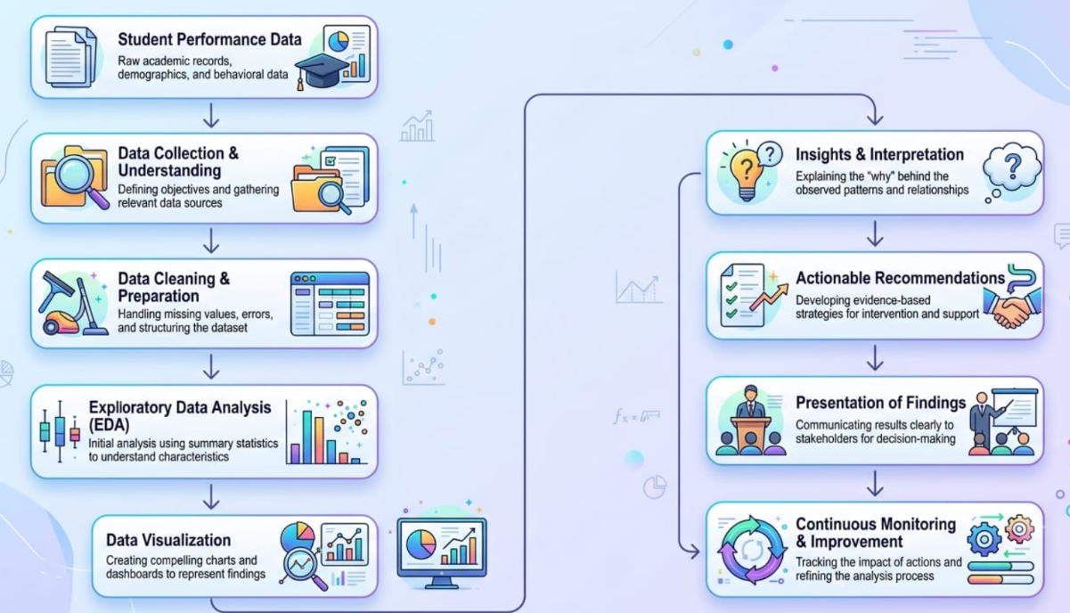

Workflow Description

1. Student Performance Data
Relevant student-related information is considered as the starting point of the analysis.

2. Data Collection & Understanding
The available variables, data types, structure, and performance measures are examined.

3. Data Cleaning & Preparation
Missing values, duplicates, inconsistent records, and unusual observations are handled appropriately.

4. Exploratory Data Analysis
The data is explored using statistical summaries and analytical techniques to identify patterns and relationships.

5. Data Visualization
Charts and graphs are used to communicate important patterns clearly.

6. Pattern Identification
Relationships between academic factors such as attendance, study time, previous scores, and performance are examined.

7. Insights & Interpretation
The observed patterns are converted into meaningful and understandable insights.

8. Actionable Recommendations
The insights are translated into possible academic support strategies and recommendations.

9. Presentation of Findings
The results are communicated to technical and non-technical stakeholders using clear visuals and simple explanations.

10. Continuous Monitoring & Improvement
Future implementations can continuously monitor performance and improve the analytical framework using updated data.

15.3 Final Project Perspective
The complete workflow demonstrates how data can be transformed into useful information and eventually into practical educational decisions.

Data → Analysis → Visualization → Insights → Action → Improvement

This final workflow represents the overall strategic approach of the proposed Student Performance Data Science project.

Final Note
This project is a hypothetical planning and reporting exercise. Actual results would depend on the quality, availability, and characteristics of a real student performance dataset.

